
Capstone Project — Phase B
User Guide
Authorship Verification Using Impostor Projections and Siamese Networks
Team Code: 26-1-R-27
Students: Ameer Masoud
Supervisor: Prof. Zeev Volkovich
Braude College of Engineering
Department of Software Engineering

Table of Contents
Table of Contents 1
1. Introduction 1
1.1 Who This Guide Is For 1
1.2 What the System Does 1
2. System Requirements 1
2.1 Accounts and Access 1
2.2 Hardware 1
2.3 Browser 1
3. The Authorship Verification Folder 1
4. Opening and Running the Notebook 1
4.1 Step 1 — Open the Notebook in Colab 1
4.2 Step 2 — Run the Setup Cells (Category A) 1
Required runtime restart 1
4.3 Step 3 — Apply Code Patches (Section 2) 1
4.4 Step 4 — Environment Check (Section 3) 1
4.5 Step 5 — Load the Data (Section 4) 1
4.6 Step 6 — Build the Model and Load the Trained Checkpoint (Sections 5–6) 1
4.7 Step 7 — Run Inference (Section 9) 1
4.8 Step 8 — Run the Improved Verdict (Section 14) 1
4.9 Step 9 — Save Results (Section 15) 1
5. Interpreting the Results 1
5.1 Confusion Matrices 1
5.2 Training Loss Curves 1
5.3 DTW Alignment Plots 1
5.4 Summary Metrics Files 1
6. Common Use Cases 1
6.1 Use Case: Reproduce the Reported Results 1
6.2 Use Case: Verify a Specific Pair of Texts 1
6.3 Use Case: Resume Without Retraining After a Disconnected Session 1
7. Troubleshooting 1
“Runtime disconnected” or session reset 1
CUDA out of memory during model construction or inference 1
“ModuleNotFoundError” right after installing dependencies 1
Numbers differ slightly from the documented results 1
8. Getting Help 1

1. Introduction
This guide explains how to operate the Authorship Verification system — a tool that determines whether two text samples were written by the same author. It is intended for end users who want to run the system on their own data, not for developers who want to modify its internals (for that, see the separate Maintenance Guide).
The system follows a research workflow rather than a live application: it runs as a sequence of cells in a single Jupyter notebook, executed inside Google Colab. There is no separate installer or graphical interface — the notebook itself is the user interface, and each section corresponds to one stage of the verification pipeline.
This guide describes the nominal flow — the steps that produce a successful run from start to finish. It does not catalog every possible error message; common issues and their fixes are covered briefly in the Troubleshooting section at the end.

1.1 Who This Guide Is For
- A user who has access to the project's Google Drive folder and wants to reproduce the authorship-verification results.
- A user who wants to run the trained model on the existing test data without retraining.
- A reviewer who wants to verify that the system runs end-to-end and produces the reported metrics.

1.2 What the System Does
Given a pair of text samples, the system:
- Splits each text into fixed-size token chunks and encodes them with a BERT-based Siamese network.
- Compares the two texts' chunk-level style signals using Dynamic Time Warping (DTW).
- Scores the comparison with an Isolation Forest anomaly detector, trained to recognize what a genuine (same-author) pair looks like.
- Outputs a verdict — genuine or impostor — along with accuracy, F1-score, and other evaluation metrics over a labeled test set.

2. System Requirements

2.1 Accounts and Access
- A Google account with access to Google Drive.
- Access to the project's shared Google Drive folder, named “Authorship Verification”, containing the trained model checkpoint, the dataset, and the project code.
- A free Google Colab account (no payment required for the steps in this guide).

2.2 Hardware
No local installation is required. All computation runs on Google's servers through Colab. A GPU runtime (the free Tesla T4 tier is sufficient) is required for running the model — the notebook will not run efficiently on CPU only.

2.3 Browser
Any modern web browser (Chrome, Firefox, Edge) with JavaScript enabled.

3. The Authorship Verification Folder
All files needed to run the system are organized in a single Google Drive folder:
MyDrive/Authorship Verification/
This folder contains:
Item | Purpose
Authorship_Verification_Final_Submission.ipynb | The main notebook — this is the file you open and run.
code/authorship_verification.zip | The full source code of the system.
data/ | The PAN20 dataset splits (train, validation, test) used for evaluation.
checkpoints/ | The trained model weights (best_model_final.pt).
results/ | Saved outputs from a previous run: metrics, confusion matrices, and plots.

Users do not need to create or modify this folder structure — it is already set up. The only action required is opening the notebook from within it.

4. Opening and Running the Notebook
This section walks through the nominal, successful path from opening the notebook to seeing final results. The notebook is organized into seven categories (A through G), each containing one or more numbered sections.

4.1 Step 1 — Open the Notebook in Colab
- Go to Google Drive and navigate to the “Authorship Verification” folder.
- Double-click Authorship_Verification_Final_Submission.ipynb. If prompted, choose to open it with Google Colaboratory.
- Once the notebook opens, confirm a GPU runtime is selected: open the Runtime menu, choose Change runtime type, and verify that T4 GPU (or better) is selected, then click Save.

4.2 Step 2 — Run the Setup Cells (Category A)
The first few cells mount your Google Drive, extract the project code, and install required Python packages. Run them in order, from top to bottom, using the Run button on each cell (or Runtime → Run all).
- A pop-up window will ask for permission to access your Google Drive — click Allow.
- The dependency-installation cell will print several lines ending in “Dependencies installed.” Lines that mention package version conflicts (for unrelated libraries such as jax or opencv) are expected and can be ignored.

Required runtime restart
Partway through Category A, the notebook will instruct you to restart the runtime (Runtime → Restart session). This step is necessary because the newly installed package versions are not recognized by Colab until the session restarts. After restarting, continue running cells from the next one onward — there is no need to repeat the cells already run.

4.3 Step 3 — Apply Code Patches (Section 2)
The cells in Section 2 rewrite several configuration and pipeline files with the project's tuned settings (training hyperparameters, the anomaly-detection method, and signal-processing options). Each cell prints a confirmation such as config.py updated. or pipeline/anomaly.py updated. when it completes successfully.

4.4 Step 4 — Environment Check (Section 3)
Run the environment-check cell. A successful run prints the active device, confirms CUDA is available, and names the GPU (for example, Tesla T4).

4.5 Step 5 — Load the Data (Section 4)
This section loads the train, validation, and test splits from the dataset folder and builds the data loaders used later in the notebook. Expect this step to take a few minutes, since it scans the underlying CSV files.
A note such as “train_pairs got 15925/20000 requested (20.4% short)” may appear. This is expected — it means some rows in the source file were skipped (for example, empty or invalid entries), but it does not indicate a failure.

4.6 Step 6 — Build the Model and Load the Trained Checkpoint (Sections 5–6)
Section 5 constructs the Siamese network. Section 6 sets the checkpoint and results folder paths.
Because a trained model is already provided, users do not need to retrain the network from scratch. Skip the Training cell (Section 7, history = trainer.train()) and instead load the existing checkpoint directly:
from training.trainer import load_checkpoint
best_path = "/content/drive/MyDrive/Authorship Verification/checkpoints/best_model_final.pt"
load_checkpoint(model, best_path, cfg.device)
print(f"Loaded checkpoint from: {best_path}")
A successful load prints the checkpoint path with no errors. Loading the trained checkpoint instead of training from scratch reduces the total run time from several hours to a few minutes.

4.7 Step 7 — Run Inference (Section 9)
This step runs the trained model over the test set, producing the style signals and feature vectors used for the final verdicts. It processes the test set in batches and prints progress every 10–50 batches. A full pass over roughly 1,600 test pairs typically takes a few minutes.
On completion, the cell reports the number of test pairs processed and their label breakdown, for example:
Extracted features for 1616 test pairs
Genuine: 795 | Impostor: 821

4.8 Step 8 — Run the Improved Verdict (Section 14)
This is the core decision step. It fits the anomaly detector using only genuine (same-author) pairs from the validation set, tunes a decision threshold to maximize F1-score, and then applies that threshold to the test set. Run the four cells in this section in order: building validation features, fitting the detector, tuning the threshold, and computing final metrics.
The final cell in this section prints the complete results, for example:
IMPROVED RESULTS
Accuracy: 0.6906 (69.1%)
F1-Score: 0.7228 (72.3%)
Precision: 0.6462
Recall: 0.8201
Genuine detection: 652/795 (82.0%)
Impostor detection: 464/821 (56.5%)

4.9 Step 9 — Save Results (Section 15)
The final cell saves all metrics, predictions, and plots back into the results/ folder on Google Drive, so they persist after the Colab session ends. A successful run prints a list of saved file paths ending in “Done.”

5. Interpreting the Results

5.1 Confusion Matrices
Two confusion matrices are produced — one for the baseline detection method and one for the improved method described above. Each matrix shows how many genuine and impostor pairs were classified correctly.
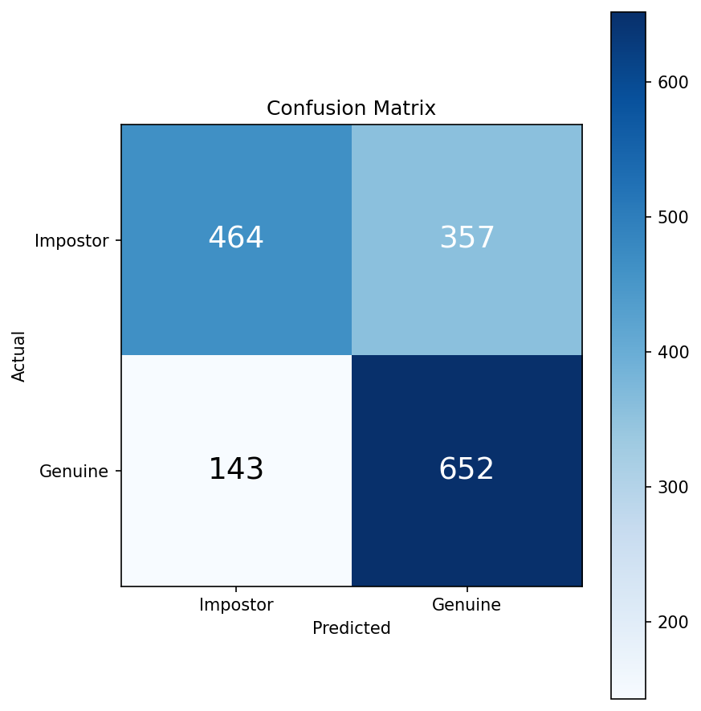
Figure 1. Confusion matrix for the improved (genuine-only fit, tuned threshold) method.

5.2 Training Loss Curves
The loss-curves plot (produced during the original training run and stored in results/loss_curves.png) shows training and validation loss across epochs, alongside the learning-rate schedule. A healthy training run shows both curves decreasing together; validation loss flattening or rising while training loss keeps falling is a sign of overfitting, which the system's early-stopping mechanism is designed to catch.
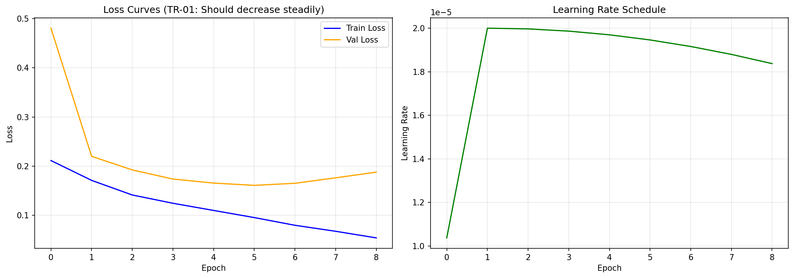
Figure 2. Training and validation loss across epochs (left) and learning-rate schedule (right).

5.3 DTW Alignment Plots
These plots visualize the style-similarity signal for one genuine pair and one impostor pair, with the optimal Dynamic Time Warping alignment between them overlaid. A genuine pair typically shows a smaller DTW distance — its style signals stay close together along most of the alignment path — while an impostor pair shows a larger distance.
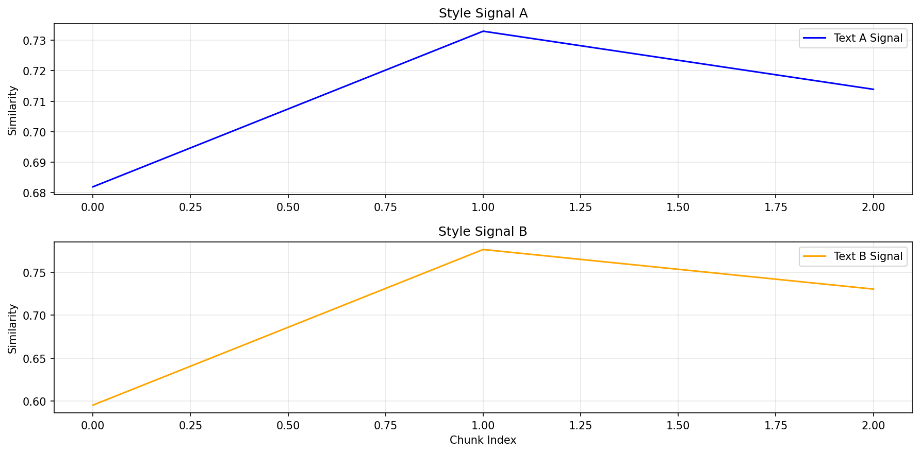
Figure 3. DTW alignment for a genuine (same-author) pair.

5.4 Summary Metrics Files
Beyond the plots, the results/ folder contains JSON files with the exact numeric results from a run:
- final_metrics.json — accuracy, F1-score, precision, and recall, for both the baseline and improved methods.
- robustness_analysis.json — genuine-detection rate, impostor-detection rate, and an overall robustness score.
- test_predictions.npz — the raw per-pair predictions and anomaly scores, for further analysis if needed.

6. Common Use Cases

6.1 Use Case: Reproduce the Reported Results
Goal: confirm that the system produces the same accuracy and F1-score reported in the project documentation, without retraining.
- Open the notebook and run Categories A through D as described in Section 4.
- Skip the training cell (Section 7); load the provided checkpoint instead (Section 4.6 above).
- Run Sections 9 through 15 in order.
- Compare the printed Accuracy and F1-Score values against results/final_metrics.json from a previous run — they should match (small variations of a fraction of a percent can occur due to floating-point and library version differences, but the overall result should be consistent).

6.2 Use Case: Verify a Specific Pair of Texts
Goal: get a verdict (genuine or impostor) for one specific pair of texts, rather than evaluating the whole test set.
This workflow is demonstrated inside Section 13 of the notebook (“Visualize DTW Alignment for a Sample Pair”), which already shows how to pick one pair from the test set, re-run the network on it, and inspect its style signals and DTW distance. To check a different pair, replace the example index used in that section with the index of the desired pair from the test set.

6.3 Use Case: Resume Without Retraining After a Disconnected Session
Goal: continue working after a Colab session disconnects, without losing previous training progress.
If training was interrupted, the Appendix section of the notebook (“Resuming Without Retraining”) explains how to identify the correct saved checkpoint by comparing the val_loss value stored inside each checkpoint_epoch_N.pt file, and how to load it directly into a freshly built model — skipping training entirely. This is the same procedure used to produce the results in this guide.

7. Troubleshooting
The following issues were encountered during development and have known, simple fixes. This is not an exhaustive list of every possible error — only the most common ones for a first-time user.

“Runtime disconnected” or session reset
Re-run the setup cells from the beginning of Category A. Google Drive will remain connected once re-mounted; the project code must be re-extracted from the ZIP file each time the runtime resets.

CUDA out of memory during model construction or inference
This should not occur with the default settings in the provided notebook, since batch size and chunk limits were tuned specifically to fit within a 16GB GPU. If it does occur, restart the runtime and re-run from the beginning without modifying the batch size or chunk-count settings.

“ModuleNotFoundError” right after installing dependencies
This happens if a package was upgraded but the runtime has not been restarted yet. Restart the runtime (Runtime → Restart session) and continue from the next cell, without repeating the install cells.

Numbers differ slightly from the documented results
Small differences (well under one percentage point) between runs are normal and expected, due to floating-point computation order and minor library-version differences. A large difference (several percentage points or more) usually indicates that the wrong checkpoint file was loaded, or that the code patches in Section 2 were skipped — re-check that all patch cells printed their confirmation messages.

8. Getting Help
For questions about the underlying methodology, architecture, or implementation details not covered in this guide, refer to the Maintenance Guide and the project book (Phase A and Phase B), both available in the project's GIT repository alongside this guide.

